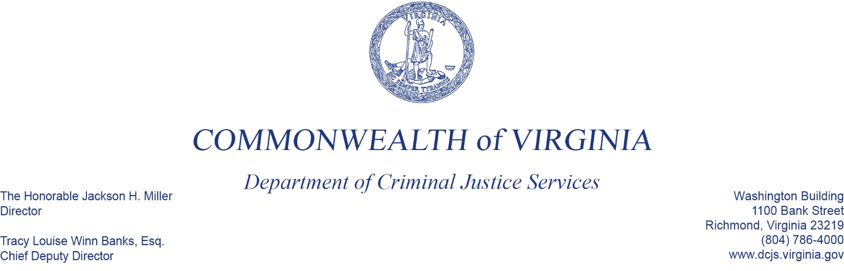
To: Criminal Justice Services Board Grants Committee
From: Kristina Vadas, Manager, Victims Services
Date: June 2, 2022
Re: Arlington Restorative Justice Program Discussion

Previously, the CJSB awarded a Victims Services Grant Program (VSGP) award and an American Rescue Plan Act (ARPA) award to the County of Arlington to support a new restorative justice program housed in the Office of the Commonwealth’s Attorney. According to their VSGP grant application:
The Office of the Commonwealth's Attorney proposes the development and launch of county-wide restorative justice program providing direct services to victim survivors of crime in the community, and direct services to victim survivors of crime and harm on select APS [Arlington Public Schools] campuses. Direct services may include listening circles, community circles, healing and harm reduction circles, conferences, conflict resolution circles, victim/offender dialogues and circles of support and accountability. It's anticipated 400 victim survivors may be served in the first fiscal year and 800 in the second fiscal year. This project will build on the work of Restorative Arlington.
After the first year of this project, the County has decided to transition the County unit implementing this grant into a legally-separate non-profit entity, Restorative Arlington. The County will remain the primary subgrantee, but is requesting to initiate a new second-tier subgrantee relationship with the nonprofit entity. The nonprofit has a designated 501(c)(3) status from the IRS. Approval of this change is pending based on Restorative Arlington successfully registering in SAM.gov, receiving a Unique Entity Identifier (UEI) number, and the initiation of a written second-tier subgrantee agreement between the County of Arlington and Restorative Arlington.
DCJS staff proposes that this change be approved, pending the successful completion of required items by Restorative Arlington.

